Envious Events Styling

Envious Events captures all aspects of our client’s imagination.

20% Service charge will apply

Envious Events Stylists will set-up and breakdown all décor.

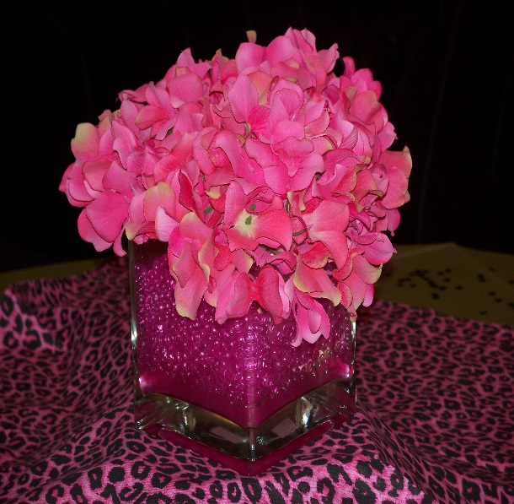
Basic Packages Include…
- Welcome Table
- Guest Tables
- Head Table
- Back Drop (single panel)
- Cake Table
These options can be added to enhance the elegance of your décor…
- Entryway to Reception
- Cocktail Area
- Name Card Table Set-Up

**Our staff would be happy to assist you with the following at no additional charge:
- Placement of Guest Favors
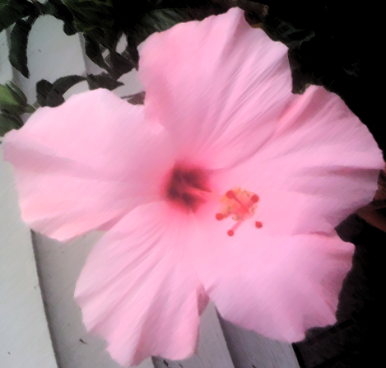
- Name/Place Card Set-Up (cards provided by client)
- Reserved / Table Number Signs & Stands
- Framed Name Sign with Easel

Social Events and Children’s Birthday Parties…
Prices vary, please contact us for rates and details.

Other services include…
Ceiling Draping, Chair Covers, Sashes, Chair Caps, Candy Buffets, Charger Plates, Linens, Fresh Flowers, Balloon Décor, Ice Sculptures, Chocolate Creations, Special Effect, Lighting and much more.

